APSC496

Project Report

**Praxim Surgical Robot**

**Authors:**

Nicolas Adams

Davy Chiu

Ibrahim Gadala

David Mountford

Erica Wodzak

**Date Submitted:**

April 19, 2010

**Word Count:**

####

# Abstract (NICHOLAS)

Table of Contents

Abstract (NICHOLAS) i

1.0 Introduction (NICHOLAS) 1

2.0 Project Background (NICHOLAS) 2

2.1 Hard Surface Emulation 2

2.2 Dynamic Physical Constraint 3

2.3 Existing Device Limitations 3

3.0 Project Scope (NICHOLAS) 4

3.1 Requirements and Specifications 4

3.2 Evaluation Criteria 4

4.0 Work Completed 6

4.1 Mechanism 6

4.2 General size and weight optimization (IBRAHIM) 8

4.3 Gravity Compensation (NICHOLAS) 9

4.4 Link and Joint Design (DAVE and IB) 9

Bone Mount Axle (BMA) 10

4.6 Error Minimization (IBRAHIM & DAVY) 12

5.0 Conclusions 13

5.1 Device Performance Tests (Nicholas) 13

Precision, accuracy and workable area testing 13

Instability 15

Results 16

Verification Testing 16

5.2 User Interface (Nicholas) 16

Virtual Weight Assessment 16

5.3 Recommendations 18

Encoder Performance 18

Software Positioning Error 19

Link Joint Play 19

Manufacturing 19

# Introduction (NICHOLAS)

The development of the Praxia prototype, described in this document, is a continuation of work in curvilinear surface generation using haptic devices completed at the University of British Columbia (UBC) by Nikolai Hungr. Prior to Praxia three-dimensional hard surface generation has been shown to be feasible, and Praxia aims to redevelop previous designs to incorporate features necessary to implement the device in a surgical environment and assess user functionality. The purpose these projects is to minimize soft tissue damage during total knee arthroplasty (TKA) by developing semi-active, bone-mounted cutting guides.

Three parties are involved with the current project; Dr. Plaskos of Praxim, Dr. Antony Hodgson a Mechanical Engineering Professor at the UBC and students from APSC 496 at the UBC. With this device, Praxim aims to target high-volume arthroplasty hospitals that perform multiple TKR procedures per day that will use the Praxia, alongside Praxim’s knee alignment system, as a low cost alternative to technologies that integrate with Computed Tomography.

This report describes key features of the design developed for this the Praxia prototype, provides an assessment of the performance of the design and discusses future work needed to develop a commercial device.

# Project Background (NICHOLAS)

The Orthopaedic surgery community continually tries to adopt new surgical techniques that minimize tissue removal in order to speed up patient recovery time and improve the quality of the surgery. Haptic devices provide one such technique and have been used to implement bone conserving implants in TKA by improving the control and accuracy the surgical procedure. Haptic devices achieve this by emulating a hard surface that can be used as a guide for the surgeon when performing operations, thereby minimizing the potential damage to soft tissue and providing the opportunities to use implants customized to individual patents.

Work completed prior to the development of the Praxia prototype focused on hard surface emulation of curvilinear surfaces with applications to knee arthroplasty. (Hungr, 2008) This project builds on designs developed by Nikolai hunger and a team of UBC students to attempt to effectively implement three-dimensional hard surface emulation of curvilinear surfaces.

This section briefly introduces the concept of hard surface emulation and the dynamic physical constraint developed by Nikolai Hunger, and summarizes the limitations of existing technologies designed for the same application.

## 2.1 Hard Surface Emulation

Hard surface emulation aids orthopaedic surgeries by restricting all bone milling and cutting to critical areas of bone, but has limited impact all other aspects of the surgery. The result is a device that allows free motion of the cutting tool away from a virtual surface aligned with the desired cutting location and impedes movement of the tool past this surface. A curvilinear surface can be implemented to optimize cutting techniques by accurately restricting the cutting tool from entering sensitive regions of bone and tissue removing only undesirable or arthritic bone in the process. Ideally feedback generated by the haptic device should only impede the user at the desired the surface and provide a precise, stiff hard surface to improve user feel.

## 2.2 Dynamic Physical Constraint

The dynamic physical constraint mechanism, developed by Hunger, utilizes a constraint that can be repositioned to impede the motion of linkages connecting a fixed surface and an end effecter, positioning the end effecter a specific distance away from the fixed surface. The concept provides the user with complete freedom of motion when not in contact with the hard surface. By updating the position of the hard constraint based on the position of the end effecter a surface can be generated. The hard constraint is implemented with a physical stopper mechanism which ensures that surface is created with infinite stiffness and allows the user to trace any continuous surface.

## 2.3 Existing Device Limitations

A number of devices, many of which are commercial technologies, have been designed to aid orthopaedic surgeries by implementing restricting tool motion. Table __ summarises the limitations of many of these devices.

* More complete review of PREVIOUS MECH 457 Prototype
* Highlight failures of existing devices, specifically MECH 457

# Project Scope (NICHOLAS)

The aim of the project was to redesign the hardware and software of an existing three-dimensional haptic interface to produce a prototype that could effectively evaluate the performance of the dynamic physical constraint mechanism in a surgical environment based on user tests. The prototype needed to be ready cadaver testing and all design decisions were to be made considering application in a sterilized surgical environment.

## 3.1 Requirements and Specifications

Requirements and specifications for the project were developed based on the limitations of previous iterations of the project, client goals and objectives and failures seen in alternate technology designed for to aid TKA. Three key specifications governed the majority of design decisions made through the course of the project;

1. The device’s hard surface constraint must be physically imposed within 0.5mm of the desired model surface.
2. The device must be able to be solidly mounted on bone/knee during surgery, completely secured with minimal movement (+/- 0.5mm).
3. The device weigh less than 5 lbs in total
4. The device’s resistance to user-directed movement away from the hard surface must be less than 10N.

## 3.2 Evaluation Criteria

A user assessment of a surgical aid such as the Praxia can be divided into two categories; (1) device precision and accuracy and (2) user feel and control.

In order to be considered for any surgical procedure the device must deliver results that meet or exceed the accuracy needed to fulfil the requirements of a surgical procedure. In this case performance relates to the effective position of the generated hard surface relative to the desired position of the surface. Device precision and accuracy is affected by the rigidity of the mechanical components and design, the accuracy of measurements of the position of the surgical tool and the reliability with which the hard constraint can be repositioned based on potential user movement. The project requirements specify that the total error generated by mechanical play and encoder position measurements should be less than 0.5mm and the total error in the connection between the device and the operating surface should be less than 0.5mm. This amounts to a total precision of +/-1mm.

The user feel and control of the device cannot be quantified as easily as precision, but an assessment of user feel must consider the ease and consistency with which an operator can position the tool. Two device characteristics have been identified as potentially influencing the user feel and control of the device. Unlike the majority of tools used in surgical procedures where the force exerted on user is always in the same direction, haptic interfaces create a situation where the force can vary based on the position of the tool. Forces too large to be easily supported by the user, or those that vary in unexpected ways will have an negative impact on the feel of the device limiting user acceptance and potentially making the device useless. The Praxia prototype limits the total force exerted on the user to 10N. The other characteristic is based on the stiffness of the generated hard surface. Hungr showed the a hard surface stiffness of 10kN is necessary to provide users with confidence in the device (Hungr, 2008).

# Work Completed

Engineering analysis and design completed in the development of the Praxim surgical cadaver prototype focuses primarily on the basic layout and design of the mechanism that will be used to implement the hard constraint and improving the speed of the system by implementing a chip that can perform floating point operations. The design presented here redevelops the four link mechanism designed previously by repositioning the hard constraint and motor at the base where the device is mounted to the bone. Significant effort has also gone into minimizing the size and weight of the device while still using materials that can be effectively sterilized. This section describes significant portions of the device’s design and design decisions that have been made, starting from an overview of the mechanism and continuing onto the link and joint designs implemented on the prototype.

## 4.1 Mechanism

The mechanism developed for Praxias prototype is pictured in Figure 1. It combines a radial link system (RLS) comprised of the primary links that implement the hard constraint and the secondary links that constrain the PLS to linear motion. The PLS is free to rotate about the y-axis around Rotating Base Axel (RBA) and is attached to link 3. Link 5 is attached to link 4 and rotates freely about the x-axis and positions the tool head connected to the device by the tool mount (TM). The TM is positions the tool head at the centre of the a radius.

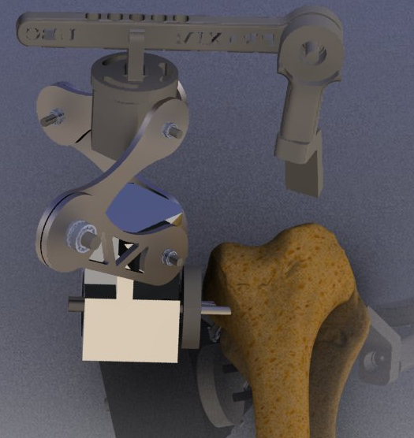

Figure : Solidworks rendering of the five link mechanism designed for the Praxim Surgical cadaver prototype

The position of the tool head can be determined by encoders placed on the rotating base (RB), at the joint between the primary links of the RLS and at the joint between link 4 and link 5. A motor positioned along the axel at the for the primary link and RB base controls the position of the hard constraint and when implemented restricts the motion the primary link to toward the RB.

## 4.2 General size and weight optimization (IBRAHIM)

The operating workspace and total weight of the device are two critical characteristics that will ultimately determine the overall success of the design. Analysis has been completed to maximize the potential workable area of the device by adjusting link lengths, while maintain the total weight of the device with the design requirements. There are two critical parameters that must be maintained, minimum workable area with a diameter of 63.5mm and a maximum total device weight of 5lbs, and any increase in workable area or decrease in the total weight of the device is beneficial to the design of the system based on user satisfaction criteria. The final link lengths shown in Table 1 have been determined by maximizing the total allowable workable area maintain the weight of the links at approximately 2lbs.

Table : Final design link lengths

|  |  |
| --- | --- |
| Link | Length [cm] |
| 1 | 7 |
| 2 | 7 |
| 3 | 5 |
| 4 | 5 |
| 5 | 7 |

Table : Joint operating range

|  |  |
| --- | --- |
| Joint Angle | Range [degrees] |
| **Ɵ12 min** | 30 |
| **Ɵ12 max** | 120 |
| **Ɵ54 max** | 45 |
| **Ɵ3** | 20 |
| **Ɵ135** | -15 |

With these link characteristics the device has a workable area of 90mm. This range has been optimized based on the user requirements determined early in the project, and ensure than there is no intereference between any of the links involved – specifically joint 1 on the primary links. Prototype testing will assess user feel to further develop the user requirements of the device based on weight and may require a reduction in the potential workable area, to improve the user performance.

## 4.3 Gravity Compensation (NICHOLAS)

One of the primary focuses of the new design is to improve the user feel of the device. A critical aspect of this is the weight of the device and tool the user must support when the tool head is away from the hard surface. Gravity compensation mechanisms can be implemented to transfer this load from the user to the support structure and bone mount. Two type of gravity compensation were considered;

* **Rotational gravity compensation** that counteracts moments produced about the bone mount due to the weight and position of the device.
* **Linear gravity compensation** that resists motion towards the bone mount that causes the radial link system to collapse.

A technical assessment of rotation gravity compensation suggests that for the theoretical design weight of the device rotational gravity compensation is not necessary, and no rotational gravity compensation mechanism has been design as a result. This assessment must be verified with user tests of a complete prototype.

A simple position adjustment mechanism coupled to the rotating base will be used to optimize the tension in a linear spring used for linear gravity compensation. The spring extends along the secondary support links of the radial link system causing a moment about the joint between secondary link 1 and secondary link 2 that counters the force of gravity on the links. User tests of the prototype will be user to optimize the spring tension for the desired operating range.

## 4.4 Link and Joint Design (DAVE and IB)

The detailed design goals for the mechanical design of the device have been driven by the need to create a device that is light and small enough to provide adequate user feel and minimize the force exerted on the bone as well as ensure the device meets performance goals. As a result the joints have been designed using minimum constraint theory and measures to ensure the joints do not become loose overtime. This section will discuss the major functions for each of the design components and provide an overview of the design for each of the components.

### Bone Mount Axle (BMA)

Functions: The bone mount axle must attach to Praxim’s adjustable bone mount and allow the rotating base to freely rotate around it. The axel must be rigidly coupled to the encoder shaft that determines the orientation of the rotating base with respect to the bone.

Design Goals:

* The bearings for the rotating base spaced as far apart as possible to minimize play in the joint
* Recess caps to minimize the size

Design:

**Rotating Base (RB)**

Functions: The RB acts as the base attachment for the device. The RB couples the primary and secondary links for the radial linkage system to the BMA and secures the hard constraint motor and BM encoder.

Design Goals:

* Design to be as easy to manufacture as possible
* Remove unnecessary weight

Design Features: Link axles are designed to be threaded in to the RB in order to avoid a press fit into the RB. The attachment points for the links are perpendicular to each other and angled 45 degrees away from the BMA to minimize interference with the soft tissue around the knee.

Recommended Improvements

Casting this part would allow for a more complicated geometry, which, in turn, could reduce the total amount of material required to accomplish its required functions; therefore, reducing the weight of the part.

**Primary and Secondary Links (PL1 and PL2)**

Functions: The primary and secondary links combine to generate a radial link system that constrains the upper connection block (Link 3) to move linearly with respect to the RB. The primary links facilitates the physical constraint preventing motion past a defined linear distance between the RB and link 3.

Design Goals:

* Minimize the size and weight of the links
* Facilitate hard constraint at primary link 1 (PL1) and shape to simplify the motor positioning function.
* Minimize the size of the joints between the two primary links and the two secondary links.

Design Features:

*Link Size*

The physical constraint function is simplified by keeping the primary links equal. 70mm links provide the necessary operating envelope and reduces the possibility of collisions between the primary link encoder and the and the physical constraint motor.

*Link Profile*

All of the links, except PL1, have a peanut shape in order to reduce the weight of the links. PL1 has the peanut profile on the top half of the link; however, the bottom half of the link is a straight edge in order to provide an edge for the physical constraint to act on.

Recommended Improvements

An area for improvement lies in the joint design. The joints have been designed to be a small as possible while still providing minimal play. A possible improvement to the design would be to simplify the machining process for the links as much as possible. Simplifying the joint design could lead to a much easier and faster assembly of the device, and reduce critical tolerances by minimizing machining error.

* Specifics of Bearing and encoder selection/design WRT to overall size of device.
* Specifics relating to looseness
* Specifics relating to manufacturing

**Horizontal Offset:**

Functions: The horizontal offset acts as a connection between the up-down motion of the primary links and the rotational motion of the links on which the tool is mounted on. The horizontal attachment is rigidly fixed to the upper rotating block on one end, and is coupled with link 5 (tool mount link) on the other. The coupling with the tool mount link incorporates an encoder, to be able to determine the position of the tool bit at all times.

Design Goals:

* Rigidity is crucial, as any deflection is a direct intrusion into the hard surface
* Remove unnecessary weight
* Allow for multiple lengths to cater to different surgical requirements

Design Features: The link is designed to be mounted above the upper rotating block with hex cap screws. An array of predrilled holes will allow for the interchanging of the link length depending on the surgery. On the tool mount side, the link width expands to a circular shape to allow for the mounting of an encoder on the back side. A through hole is made so that the encoder shaft can interact with the tool mount link on the front side.

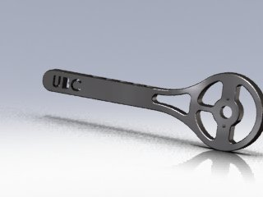

Recommended Improvements

A reduction in the link size can be achieved if a smaller encoder is found, that achieves the required precision and mounting orientation. Also, a more convenient length interchanging design could be implemented, which can allow “on-the-fly” length changes during the surgery itself, rather than dismantling the whole link and assembling it to the new size.

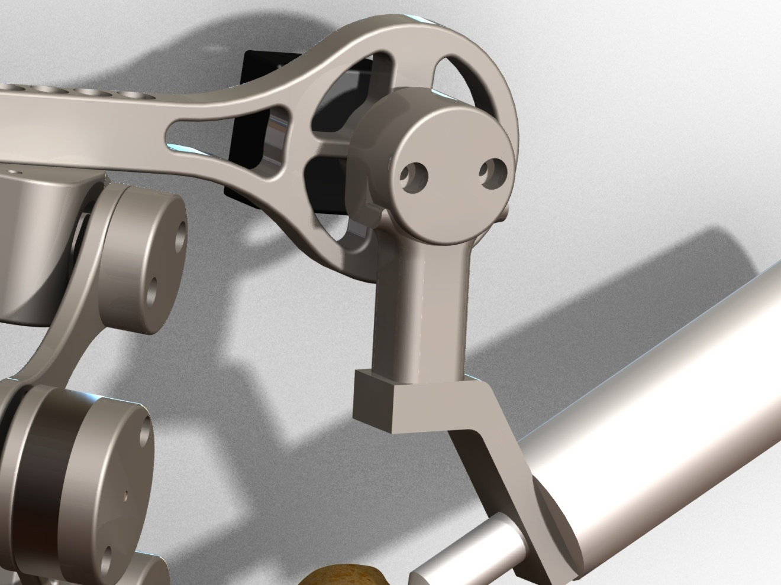

**Link 5 (L5):**

Functions: Link 5 is a crucial part of the design, since its movement allows for the negotiation of curves in the hard surface more than the other dynamic links of the robot. Link 5 rotates about a shaft which is coaxial to the encoder shaft running through the horizontal offset. Thus, link 5 rotates in a plane parallel to the horizontal offset link. The movement of link 5 adds width and depth to the workable area.

Design Goals:

* Minimize resistance to user movement (as smooth as possible)
* Remove unnecessary weight
* Reduce size, without compromising load-bearing capability

Design Features: The link is designed to simply be a downward vertical addition to the horizontal offset, able to rotate about a joint shaft between them. It comprises of two parts, the actual vertical link, and the cap. The link itself tackles the main functionality of providing a downward vertical arm for the robot, while the cap houses the bearing assembly (for smooth motion) and serves as the end-mount for the encoder shaft. Since the encoder is mounted on the “static” horizontal offset, the motion of link 5 can be determined by simply measuring the rotation of the encoder shaft.

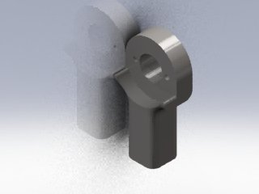

Recommended Improvements

An amalgamation of link 5 and the tool mount link (described below) could allow for a more compact and light weight design.

**Tool Mount Link:**

Functions: The tool mount link is the final link of the design and is the one on which the surgical tool is mounted. The link allows for rotation about the axis of link 5, thus giving the surgeon the ability to hold the tool from virtually any angle. The tool mount link does not allow translational movement in itself, however, as it is attached to link 5 and the rest of the structure, it also moves in the up-down direction as allowed by the primary links.

Design Goals:

* Full 360° freedom rotation about the link 5 axis
* Maintain structural integrity while bearing the full weight of the tool

Design Features: The tool mount link is designed to couple with bottom of link 5 with a joint fastener (shoulder screw) that threads into link 5, providing the necessary constraint against translational movement and allowing the free rotational movement. The interface between the link and the tool is at an angle in order for the tool bit to always touch the cutting surface using its side, for optimal cutting performance.

Tool mont link picture here.

Recommended Improvements

Making the tool rotation with respect to the tool mount link lets the surgeon’s hand follow a more natural and comfortable sculpting motion. This additional degree of freedom does not improve the function of praxima itself, but allows the surgeon to be less constrained and more relaxed during the surgical procedure.

## 4.6 Error Minimization (IBRAHIM & DAVY)

* Mechanical hardware selection
* Electrical hardware selection
* Software design

# Conclusions

The Praxim haptic surgical aid aims to assess two major concept goals necessary to implement an effective device to facilitate knee surgeries.

1. Device Performance: Does the device do what it should be able to do?
2. User Interface: Is the device user-friendly? How well does the device interact with the user?

Tests have been designed to evaluate the prototype design based on these goals.

## 5.1 Device Performance Tests (Nicholas)

The device performance tests determine whether the device will provide the precision and accuracy necessary to be considered an acceptable surgical aid. Concept specifications require that the hard surface constraint is physically imposed within 0.5mm of the desired model surface. This means that the device must recognize the current position of the tool to within a 0.5mm total displacement based on all encoder readings and play in linkage joints. The device must also provide a total work space to implement a common uni-compartmental implant. This has been approximated as a circle with a radius of 63.6mm.

### Precision, accuracy and workable area testing

In order to assess the precision of the device the position of a number of points must be known to a greater accuracy the required precision of the device. This can be achieved by using a mill with a known accuracy of +/-0.05mm to locate and mark four calibration positions on a piece of carbon steel with a coefficient of linear expansion of 13.0E-6 m/m K. Allowing for a 100K temperature variation the mark positions will be known to within +/-0.05mm. The device accuracy can be determined by comparing the device location with the actual position of the milled marks.

|  |  |  |
| --- | --- | --- |
| Step | Task | Comments |
| 1. | **Mill Calibration Positions**   |  |  | | --- | --- | | 1. | Clamp an approximately 6cm by 6cm by 1cm piece of scrap carbon steel in the mill vice. | | 2. | Use edge finder tool to position the mill at a corner of the steel. Replace edge finder with a 0.2mm drill bit and reposition the z-coordinate at the surface of the device. Zero all dimensions. | | 3. | Use the mill to make holes 1mm deep holes at four positions [(40mm, 40mm); (40mm, 10mm); (10mm, 40mm); (10mm, 10mm)] | | 4. | Clamp steel in a vertical orientation and complete steps 1.2 and 1.3 at [(5mm, 10mm); (5mm, 40mm)] | | Try to drill each hole quickly and use coolant to avoid heating metal excessively. Actual position of calibration points may vary. Record any changes on the testing procedure. |
| 2. | **Create holes for bone mount**   |  |  | | --- | --- | | 1. | On a flat surface of the steel create two 5mm holes 10mm apart using a 2.5mm drill bit. | | 2. | Tap the holes using a 3.3mm tap | |  |
| 3. | **Device Precision**   |  |  | | --- | --- | | 1. | Connect device to carbon steel piece designed above through the bone mount using two m3 screws | | 2. | Connect a pin to the tool end so that the pin head is positioned at the centre of the radius of curvature of the tool. | | 3. | Place the tool at the calibration corner of the steel piece and record the encoder determined position. | | 4. | Place the tool at the marks located at [(40mm, 40mm); (40mm, 10mm); (10mm, 40mm); (10mm, 10mm)] and record the encoder determined position. | | 5. | Place the tool at the marks located at [(5mm, 10mm); (5mm, 40mm)] in the vertical plane and record the encoder determined position. | |  |
| 4. | **Device Accuracy**   |  |  | | --- | --- | | 1. | Repeat step 3 five times | | 2. | Graph the actual mark positions as well as each test position. | |  |
| 5. | **Workable Area**   |  |  | | --- | --- | | 1. | Position tool at the calibration corner with a piece of paper positioned below the steel piece. | | 2. | Trace the tool head through each of the steel marks and ensure the tool head does not leave the surface of the steel piece. Can this be completed effectively? | | 3. | Move the tool head towards each of the corners of the piece of paper. Record the device reach to each of the corners on the piece of paper. | | 4. | Keeping the x and y coordinates the same as step 5.3 record the highest possible vertical position. | | This test does not determine the volume of the device, but provides a basic footprint range and will verify that the device will be effective for the implant sizes considered. |

### Instability

Tests of previous prototypes identified the presence of instabilities at corner positions. The hard surface position and any potential instability can be determined by tracing the surface of various hard surfaces.

|  |  |  |
| --- | --- | --- |
| Step | Task | Comments |
| 6. | **Hard Surface**   |  |  | | --- | --- | | 1. | Clamp a piece of foam to the steel testing piece created in step 1. | | 2. | Implement four models into the system (flat, spherical bulge, cone and pyramid) | | 3. | Slowly trace the surface of the foam for each of the shapes, removing excess material and revealed the implemented shape. Not down any positions where the tool head penetrates the hard surface | | 4. | Place the tool head at any corners. Access the stability of the tool at these locations. | | Tool should not penetrate the hard surface. |
| 7. | **Instability**   |  |  | | --- | --- | | 1. | For each of the shapes implemented above place the tool head at any corners. Access the stability of the tool at these locations. | | Tool instability should be maintained to within +/- 1mm. |

### Results

Testing has not been completed

### Verification Testing

* Device positioning code based on encoder values – hand calcs
* Tests that ensure encoders read position properly
* Test setup

## 5.2 User Interface (Nicholas)

The user feel of the device is essential for wide spread acceptance and has been a major focus of the current design. Previous prototypes confirmed that 3D haptic surfaces could be implemented effectively, but proved hard to control due to a resistance to user movement termed “virtual weight”. User based tests will be used to determine the effectiveness of the device as a bone sculpting tool.

### Virtual Weight Assessment

|  |  |  |
| --- | --- | --- |
| Step | Task | Comments |
| 8. | **Virtual Weight**   |  |  | | --- | --- | | 1. | For each user: Setup device using foam and implement a hemi spherical hard surface. The foam must be cut to within 5mm of the hard surface prior to testing. | | 2. | With a black pen, place point pairs 5cm apart in a zigzag pattern at 1 cm intervals and mark transition paths across the surface points – use a total of 10 points. | | 3. | In an orientation perpendicular to the step 8.2, repeat step 8.2. | | 4. | Position user 45 degrees from the bone mount position and a line connecting the hip and the knee. | | 5. | Make user follow the zigzag paths described in 8.2 and 8.3, pausing at each point for 5 seconds. Each transition should take between 3 and 5 seconds. | | 6. | Ask user to rate the device performance based on the scale shown in step 8 comments. | | 7. | Ask user to provide general comments on the perceived effectiveness of the device for high precision cutting applications. | | 8. | Measure and record the maximum error between the cut path and desired path. | | Testing using foam will not provide the same resistance as a bone, but be used to assess the effects of the weight of the device on the user in different orientations while performing surgical type operations. The user assessment scale is based on the user’s perceived control over the position of the device and the user’s ability to maneuver the tool along a specific path.   |  |  | | --- | --- | | Rating | Description | | 1. | Device is uncomfortable to hold, will not follow desired path and requires excessive effort to maintain position | | 2. |  | | 3. | Device is uncomfortable to hold, somewhat follow desired path and requires effort to maintain position | | 4. |  | | 5. | Device is uncomfortable to hold, follows desired path and requires effort to maintain position | | 6. |  | | 7. | Device is comfortable to hold, follows desired path well and can maintain position with limited input | | 8. |  | | 9. | Device is comfortable to hold, follows desired path well and can maintain position without user input | | 10. | Device does not affect user control of the tool. | |
| 9. | **Accessibility**   |  |  | | --- | --- | | 1. | For each user: Setup device using foam and implement a hemi spherical hard surface. The foam must be cut to within 5mm of the hard surface prior to testing. | | 2. | With a black pen, place point pairs 5cm apart in a zigzag pattern at 1 cm intervals and mark transition paths across the surface points – use a total of 10 points. | | 3. | In an orientation perpendicular to the step 8.2, repeat step 8.2. | | 4. | Position user 45 degrees from the bone mount position and a line connecting the hip and the knee. | | 5. | Make user follow the zigzag paths described in 9.2 and 8.3, pausing at each point for 5 seconds. Each transition should take between 3 and 5 seconds. | | 6. | Ask user to rate the device performance based on the scale shown in step 9 comments. | | 7. | Ask user to provide general comments on the perceived effectiveness of the device for high precision cutting applications. | | 8. | Measure and record the maximum error between the cut path and desired path. | | This assessment should be completed by experienced surgeons.   |  |  | | --- | --- | | Rating | Description | | 1. | Device is does not provide access critical locations | | 2. |  | | 3. |  | | 4. |  | | 5. | Device is allows access the all critical locations, but requires undesirable repositioning of hand | | 6. |  | | 7. |  | | 8. |  | | 9. |  | | 10. | Device provides comfortable access to all desired areas. | |

# Recommendations

User tests and performance evaluations have not been completed because the prototype is not yet fully functional. Basic performance tests have been used to evaluate the encoder performance based on the update speed and the consistency of each reading, and the software has been verified using hand calculations. The majority of the mechanical aspects of the design require user tests, but an evaluation of the manufacturing techniques can be provided based on machining and fabrication analysis. Once prototype construction and user tests have been completed, a review of the prototype will be presented to the client and a formal list of recommendations will be compiled from the findings.

### Encoder Performance

The encoders pick up 100% of repositions and position the tool within 0.17mm of the desired position if mechanical play is ignored. This allows for 0.3mm of additional error from the bone mount joint, play at the links and software rounding errors. The design uses relative encoders and the total performance maybe limited by accuracy of the calibration position as a result. The calibration position accuracy will not be known until the prototype has been completely manufactured.

### Software Positioning Error

The software designed takes encoder input and computes the desired user position. Related error occurs due to rounding in the position identification and bugs in the software the computer the wrong position in certain circumstances. No errors have been found in current version of the code and all variables maintain 16 decimal places, so there is negligible error in the software as a result.

### Link Joint Play

Manufacture of the prototype has been rushed resulting in a significant increase in play in the joints. An assessment of the maximum in the primary, hard constraint, joints shows a play in the joints of approximately 5 degrees, amounting to +/-6mm of error. Combining the primary and secondary links to create the radial link structure reduces the error to 1mm; however this error is unacceptable for surgical purposes. Manufacturing techniques must be considered further to ensure the desired tolerances for critical components can be met.

### Manufacturing

Manufacturing of the prototype has been completed using a combination of water jet cutting and machining. The complexity of the links necessary to reduce the overall weight of the system makes accurate machining difficult. As a result, a combination of casting and CNC is recommended for additional devices. Casting should be used for the rotating base and the tool mount while minor changes made to the current design could allow for complete manufactured using water jet and CNC.

**6.0 References and Appendices**

**6.1 References**

1. Mech451/2 Praxim Project Final Report, 2008

2. Haptic Emulation of Hard Surfaces with Applications to Orthopaedic Surgery, Nikolai Hungr, 2008